Nolan Anderson
EE 384 Classwork 1 Due 29 August 2021
***Functions are at the bottom of report***

Notes
clc
clear all
close all

Problem 1
% 1.1 Unit Impulse
n_p = 0; n1 = -5; n2 = 5;
[y, n] = u_impulse(n_p, n1, n2);
figure
stem(n,y), xlabel('n'), ylabel('y(n)')
title('Unit Impulse | 1.1')
% 1.2 Unit Step
n_s = 0; n1 = -5; n2 = 5;
[y, n] = u_step(n_s, n1, n2);
figure
stem(n,y), xlabel('n'), ylabel('y(n)')
title('Unit Step | 1.2')
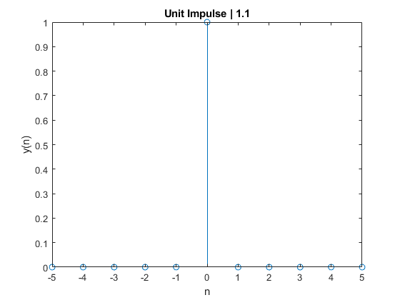
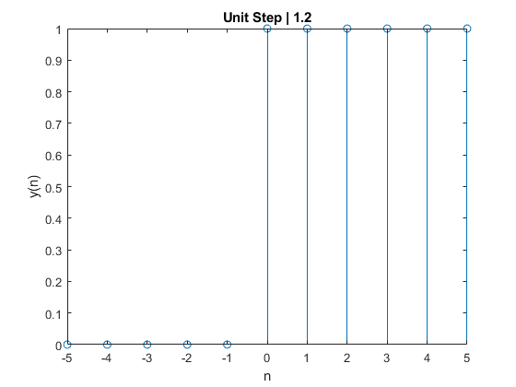

Problem 2
% 2.1 see Functions section.
% 2.2
n = -10:10; x = 2 * n + 3; figure
stem(n, x), xlabel('n'), ylabel('x'), title('x(n) = 2n + 3 | 2.2a')
[x_2, n] = time_shift(x, n, 3); figure
stem(n, x_2), xlabel('n'), ylabel('x'), title('x(n) = 2(n+3) + 3 | 2.2b')
[x_3, n] = time_reverse(x, n); figure
stem(n, x_3), xlabel('n'), ylabel('x'), title('x(n) = -2n + 3 | 2.2c')
% 2.3
figure
n = -10:10;
[y1, m] = u_impulse(-4, -10, 10);
[y2, m] = u_impulse(2, -10, 10);
y = 5*y1 -2*y2;
stem(n, y), title('y(n)=5*imp(n+4) - 2*imp(n-2) | 2.3')
ylabel('y(n)'), xlabel('n')
% 2.4
figure
[z1, m] = u_step(0, -10, 10);
[z2, m] = u_step(4, -10, 10);
z = z1 - z2;
stem(n, z), title('y(n)=u(n) - u(n-4) | 2.4'), xlabel('n'), ylabel('y(n)')
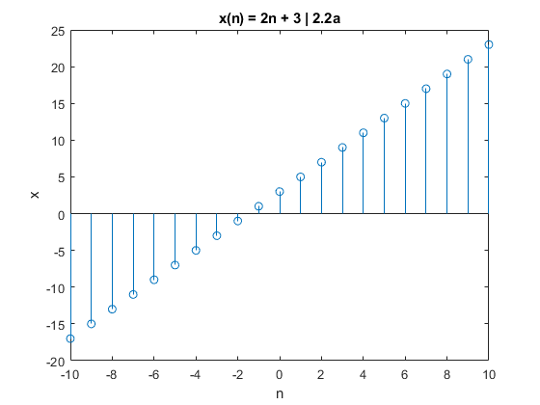
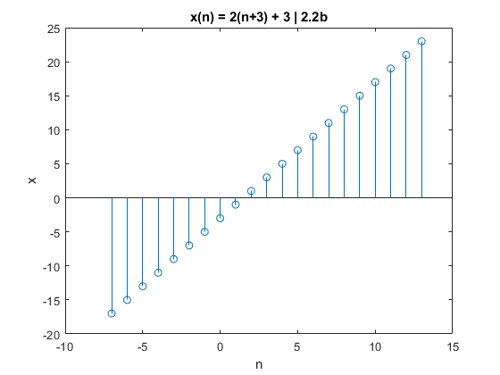
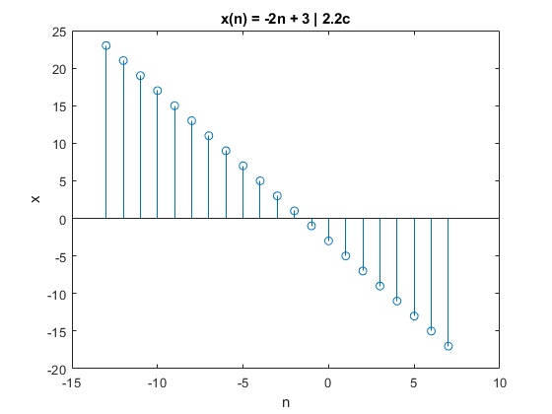
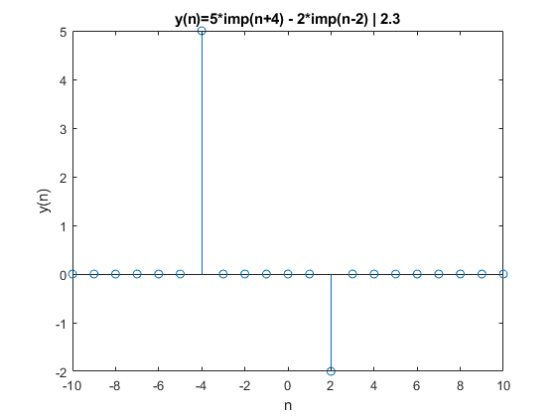
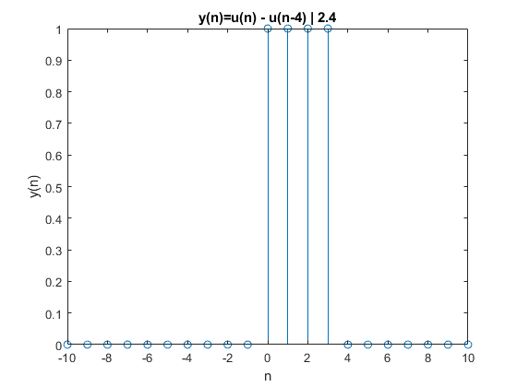

Problem 3
% 3.1
load('SAMPLE_ECG.mat');
x = ECG_Data;
figure
plot(x), title('x(n) | 3.1'), axis([0 2000 100 220])
% 3.2
for i = 1 : length(x) - 2
y(i) = (x(i) + x(i + 1) + x(i + 2)) / 3;
end
% 3.3
figure
subplot(2, 1, 1), plot(x), title('x(n) | 3.3'), axis([0 2000 100 220])
subplot(2, 1, 2), plot(y), title('y(n) | 3.3'), axis([0 2000 100 220])
% 3.4
% Yes it is smoother. You can tell that there aren't as many spikes between
% the values > 200.
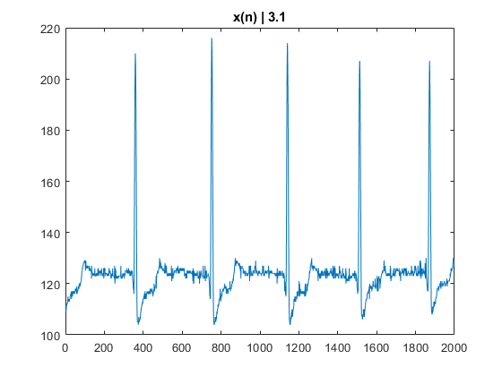
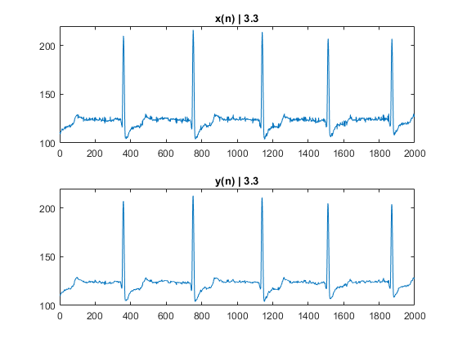

Functions
% Unit Impulse
function[y, n] = u_impulse(n_p, n1, n2)
n = n1 : n2;
y = (n - n_p) == 0;
end
% Unit Step
function[y, n] = u_step(n_s, n1, n2)
n = n1 : n2;
y = (n - n_s) >= 0;
end
% Time Shift
function[x, n] = time_shift(x, n, n_d)
n = n + n_d;
end
% Time reversal.
function[x, n] = time_reverse(x, n)
n = -n;
end
Published with MATLAB® R2020b

